0Part 1
1. Evaluate the following expressions for num1 = 10 and num2 = 20.
(a) not (num1 < 1) and num2 < 10
(b) not (num1 < 1) and num2 < 10 or num1 + num3 < 100 (c) not (num2 > 1) or num1 > num2 - 10
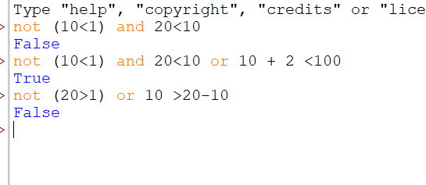
2. Give an appropriate if statement for each of the following
(the value of num is not important):
- Displays 'within range' if num is between 0 and 100, inclusive.
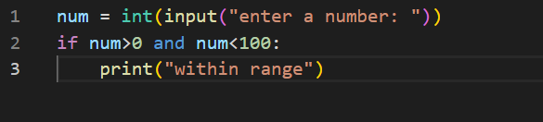
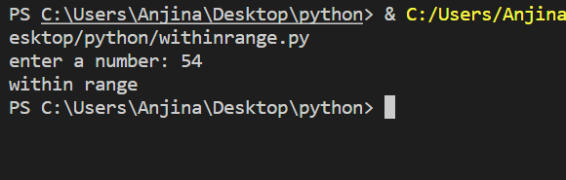

- Displays 'within range' if num is between 0 and 100, inclusive, and displays 'out of range' otherwise.
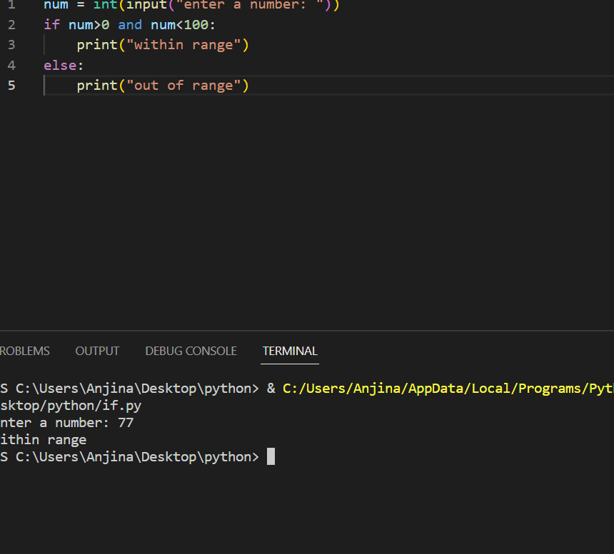
3. Rewrite the following if-else statements using a single if statement and elif:
if temperature >= 85 and humidity > 60:
print ('muggy day today')
else:
if temperature >= 85:
print ('warm, but not muggy today')
else:
if temperature >= 65:
print ('pleasant today')
else:
if temperature <= 45:
print ('cold today')
else:
print ('cool today')
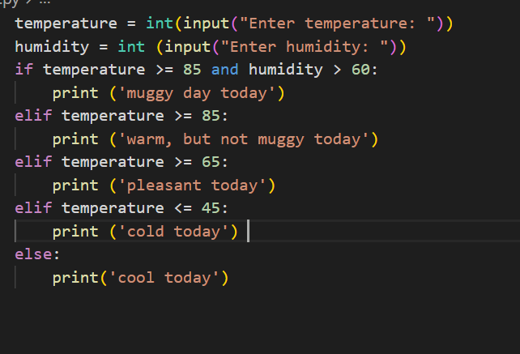
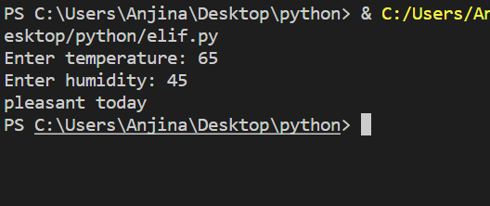
4. Write a Python program in which:
(a) The user enters either 'A', 'B', or 'C'. If 'A' is entered, the program should display the word 'Apple'; if 'B' is entered, it displays 'Banana'; and if 'C' is entered, it displays 'Coconut'. Use nested if statements for this.
(b) Repeat question (a) using an if statement with elif headers instead.
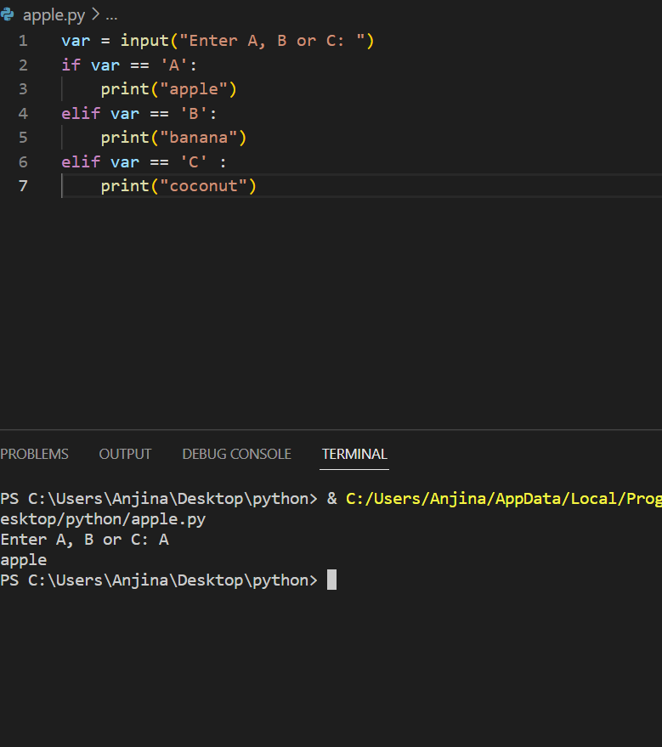

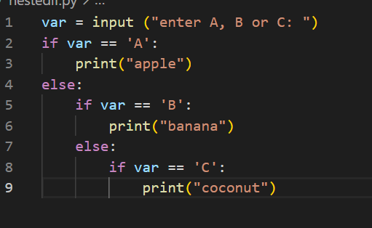
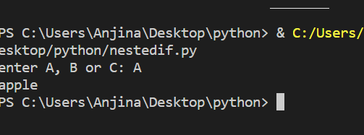

c) A student enters the number of college credits earned. If the number of credits is greater than or equal to 90, 'Senior Status' is displayed; if greater than or equal to 60, 'Junior Status' is displayed; if greater than or equal to 30, 'Sophomore Status' is displayed; else, 'Freshman Status' is displayed.
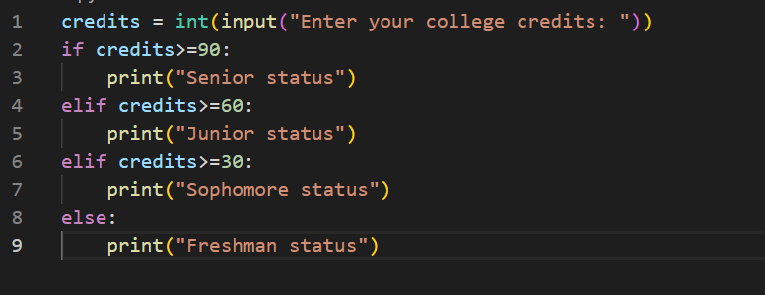
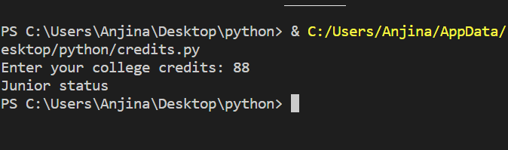

(e) The user enters a number. If the number is divisible by 3, the word ‘Fizz’ should be displayed; if the number is divisible by 5 the word ‘Buzz’ should be displayed and if the number is divisible by both ‘FizzBuzz’ should be displayed.
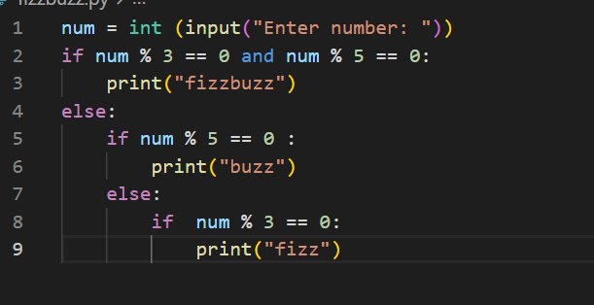
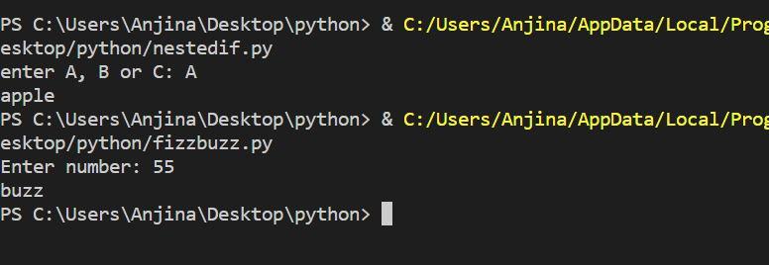

5. Sam wants to store his series of car to a list. The list of a car are: (up to you). After creating a list he add some car and delete some car and at last there are still 5 cars left in his list. Additionally, he wants his car to be shuffled every time when the list is being displayed. [Hint: shuffle from random]
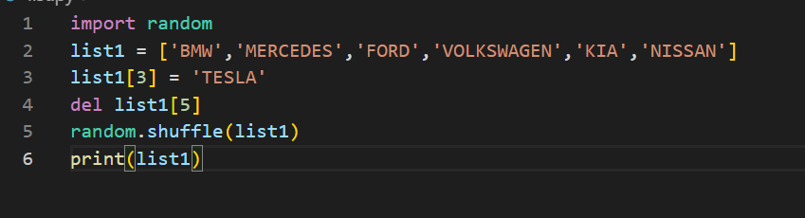
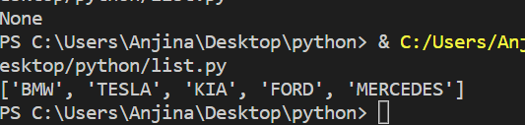

Part 2
1. Write a program that:
(a) Uses a loop to add up all the even numbers between 100 and 200, inclusive.
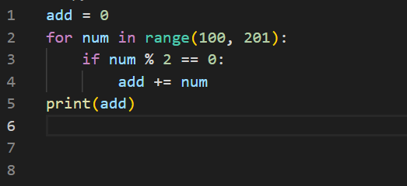
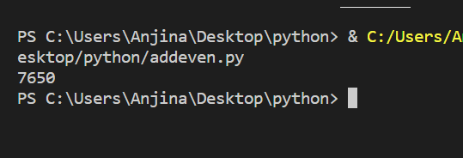
- Sums a series of (positive) integers entered by the user, excluding all numbers that are greater than 100.
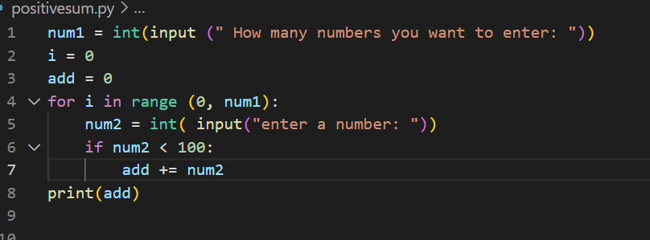
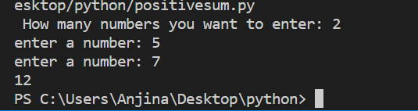

- Solves Q2 but this time using an infinite loop, break and continue statements.
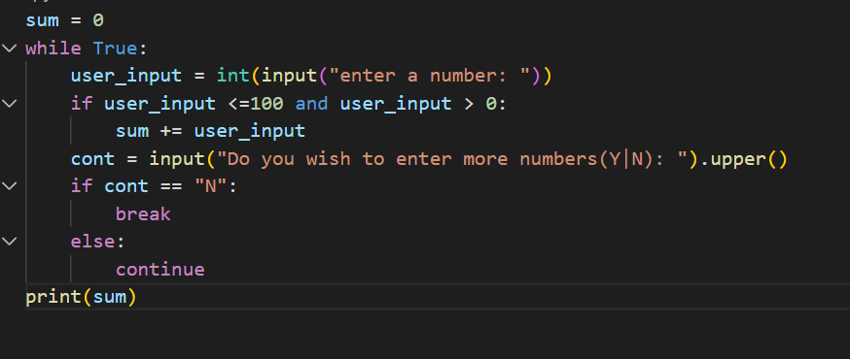
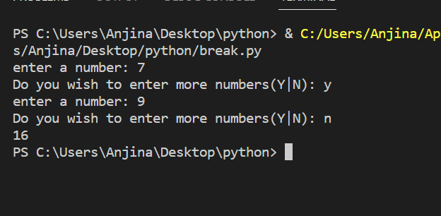
- Prompts the user to enter any number of positive and negative integer values, then displays the number of each type that were entered.
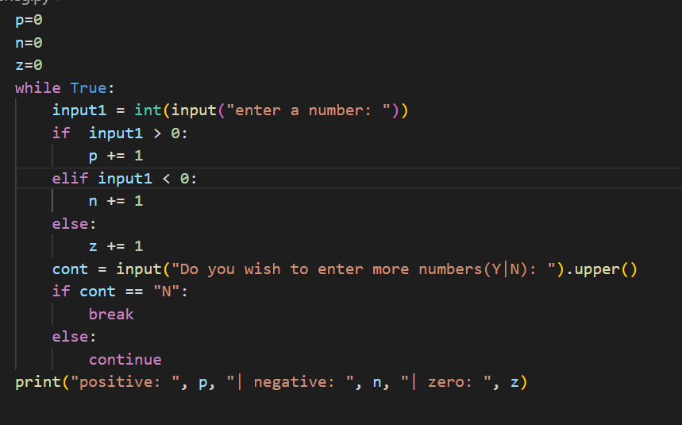
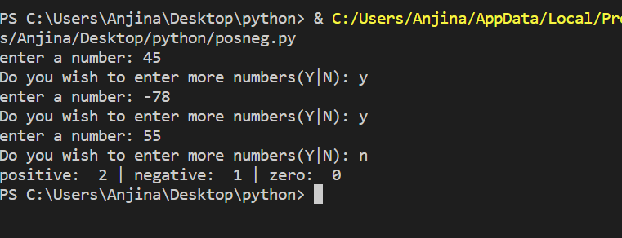
2. The following while loop is meant to multiply a series of integers input by the user, until a sentinel value of 0 is entered. Indicate any errors in the code given. See if you can fix the program and get it running.
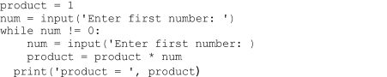

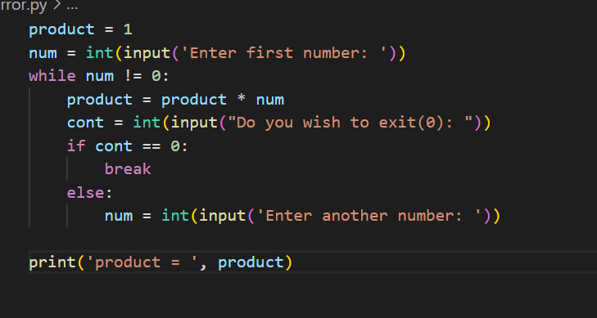
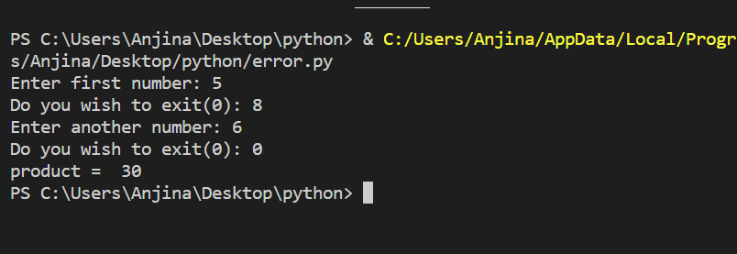
3. For each of the following, indicate which the definite loop is, and which an indefinite loop, explain your reasoning.
(a)
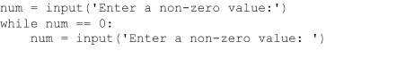(b)
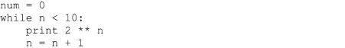
A is indefinite loop because the value of num is not increased. So it will always be 0.
B is definite loop because the value of n increase by 1 everytime.

Part 3
1. Create three dictionaries:
dic1 = {1:10, 2:20} dic2 = {3:30, 4:40} dic3 = {5:50, 6:60}
- Write code to concatenate these dictionaries to create a new one. Create a variable called nums to store the resulting dictionary. There are multiple ways to do this, however, one of the easiest is to convert each of the dictionaries items to a list (which can be added together) and pass them to the dict() constructor.
- Write code to add a new key/value pair to the dictionary nums: (7, 70)
- Write code to update the value of the item with key 3 in nums to 80
- Write code to remove the third item from dictionary nums.
- Write code to sum all the items in the dictionary nums
- Write code to multiply all the items in the dictionary nums
(g) Write code to retrieve the maximum and minimum values in nums.
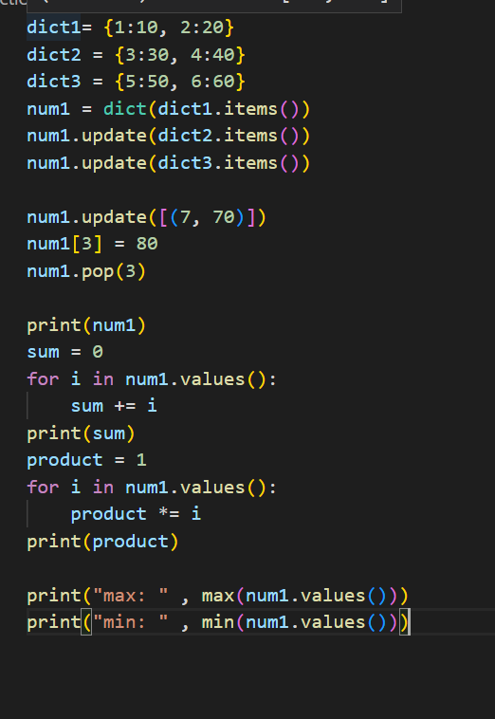
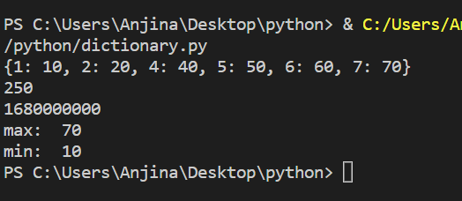
3. Create a dictionary named password_lookup that contains usernames as keys and passwords as associated string values. Make up data for five entries.
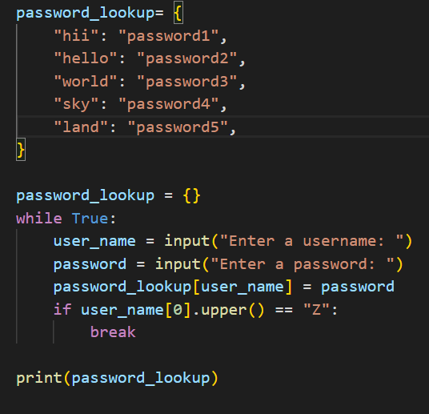

4. Write a program that creates an initially empty dictionary named password_lookup, prompting one-by-one for usernames and passwords
(until a username of 'z' is read) entering each into the dictionary.
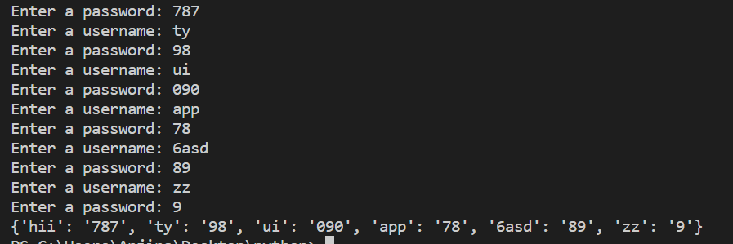

5. Create a dictionary named password_hint that contains email addresses as keys, and associated values that contain both the users’ “password security question,” and the answer to the question. Make up data for dictionary entries.
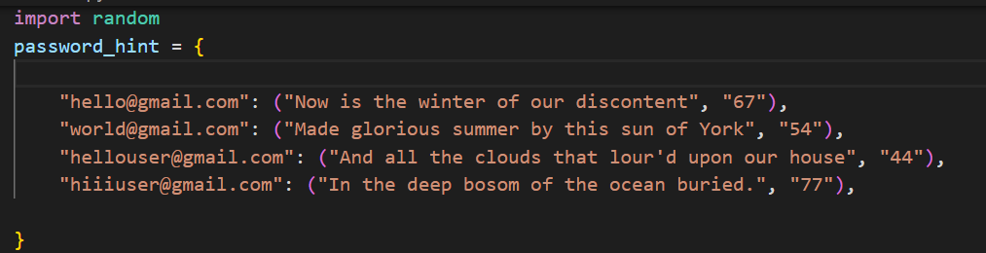
6. Create a dictionary named member_table that contains users’ email addresses as keys, and answers to their password hints as the associated values, and a function that generates a temporary new password and stored in the table.

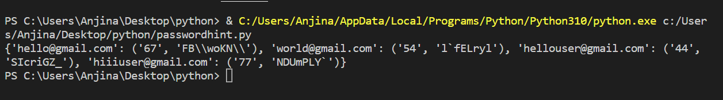
Part 4 (Home Task)
- The hangman game introduces many new concepts like methods, which are functions attached to values. You’ll also need to learn about a data type called a list. Once you understand these concepts, it will be much easier to program Hangman.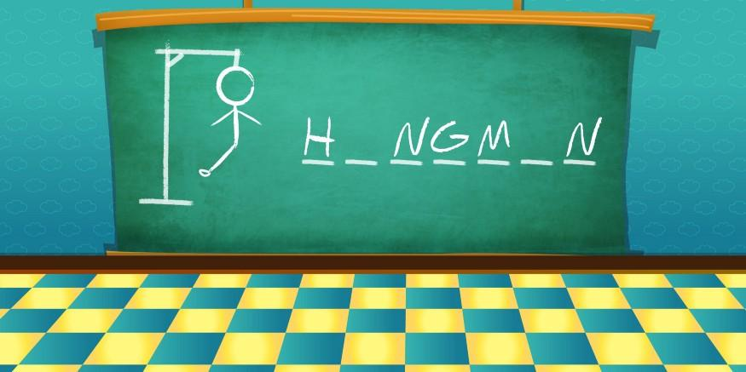
- You will need random module.
You will need to use the concept of list.

